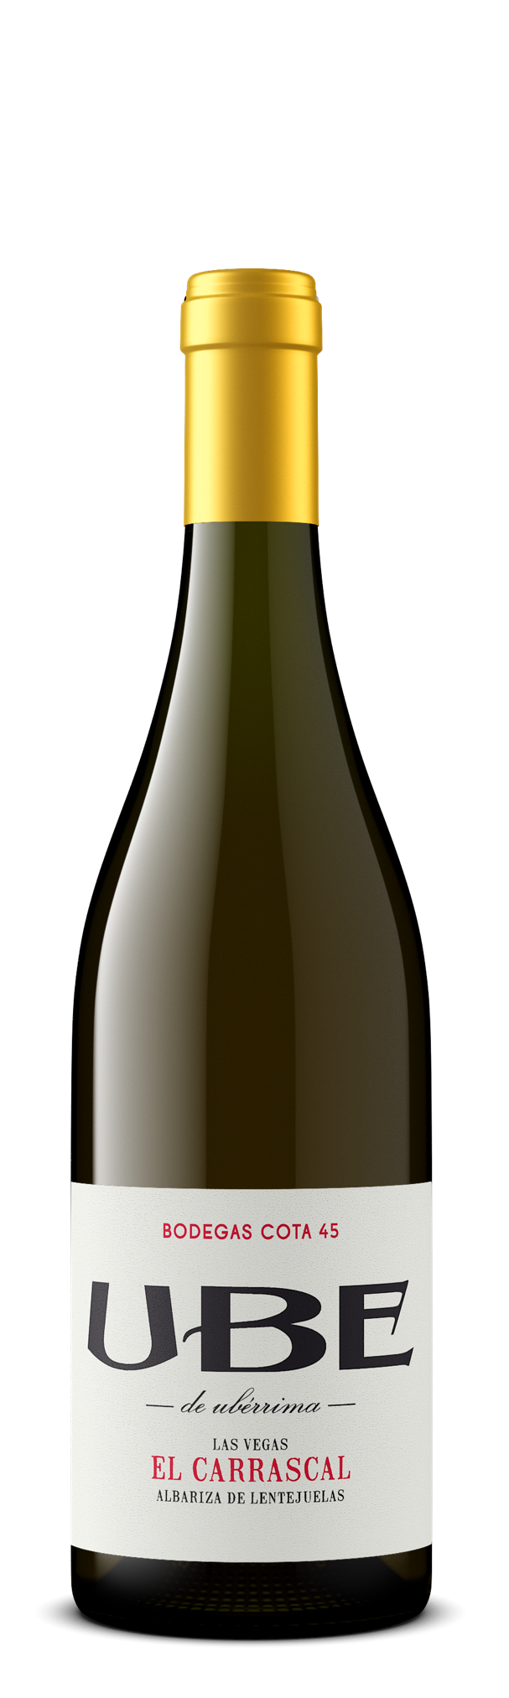
Origin
Sanlúcar de Barrameda, Cádiz, Andalucía.
Varieties
100% Listán (Palomino).
Vineyard
From the 0.7 Las Vegas vineyard in the El Carrascal pago in Sanlúcar.Carrascal is the closest pago to the coast of any pago in the Sherry area at 5km, and the soils are sand and delicate “lentejuelas” albarizas.
Vinification Method
Grapes are harvested by hand then pressed whole-cluster into old botas, where the juice spontaneously ferments without temperature control. After racking, the wine remains in the same bota for 2-3 years and ages under flor for a portion of that time.

Producer Profile
To revive tradition and fully express the unique terroir of Jerez are the goals of Ramiro Ibáñez, the talented mind behind Cota 45. Ramiro is one of the most knowledgeable winemakers in Jerez, the storied region in southern Spain. A Jerez native, he graduated with a degree in enology and spent 3 years working around the world before returning home in 2009. Since then, he has been consulting for three different bodegas, and in 2012 was able to start his own project. He lovingly refers to his bodega as his “albarizatorio,” or a lab for unearthing the best that this legendary, white-chalk soil has to offer. The name is a reference to 45 meters above sea level, the point where he believes the best albariza soils can be found.

